**Multiple choice practice**

**Part A**

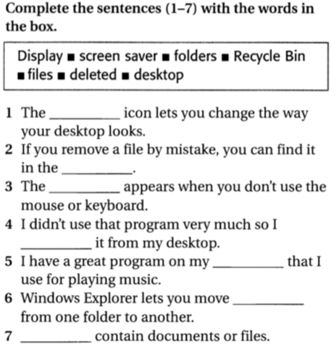

**Part B**

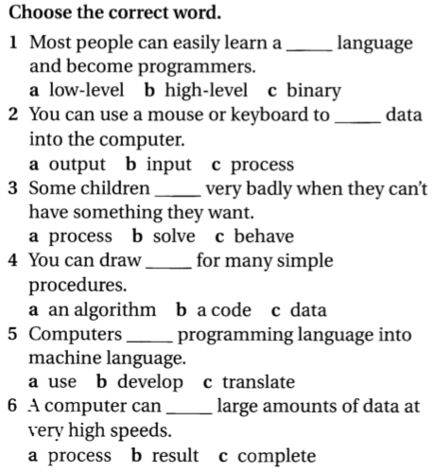

**Part C**

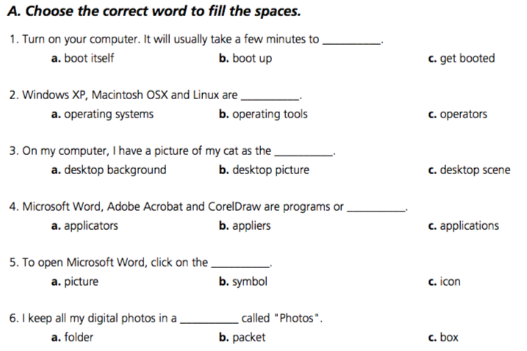

**Part D**

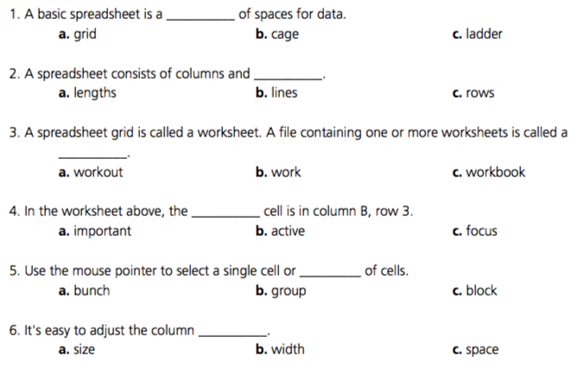

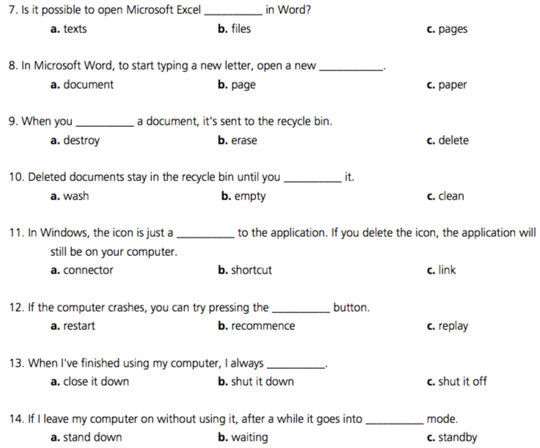

**Part E**

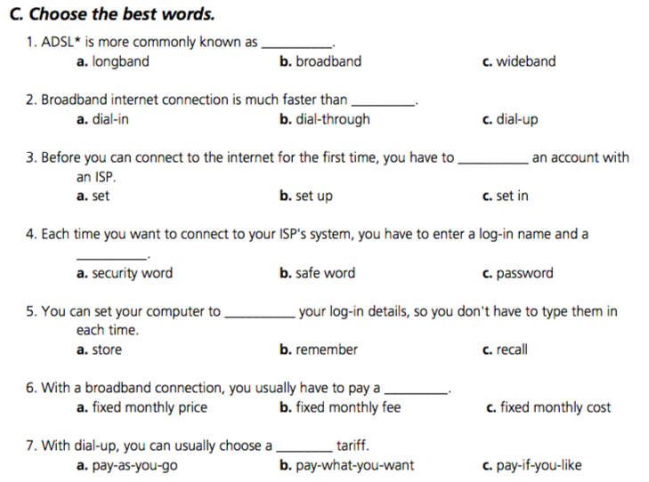

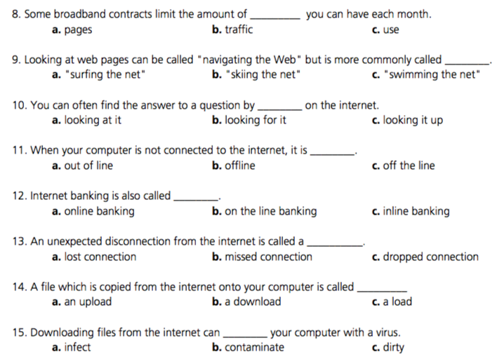

**Part F**

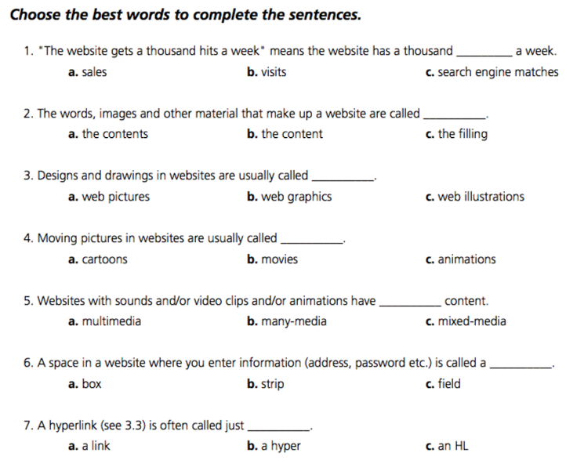

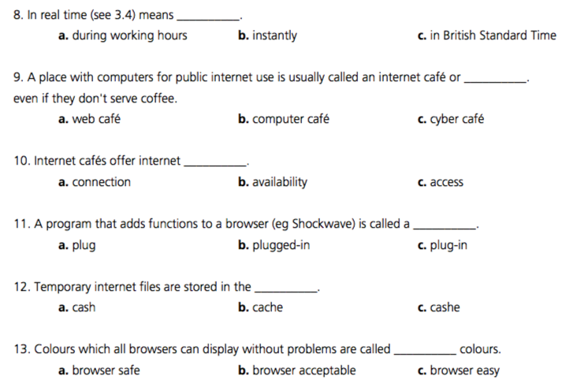

**Part G**

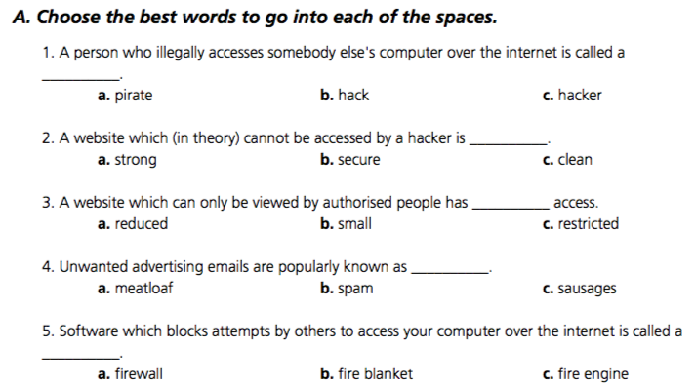

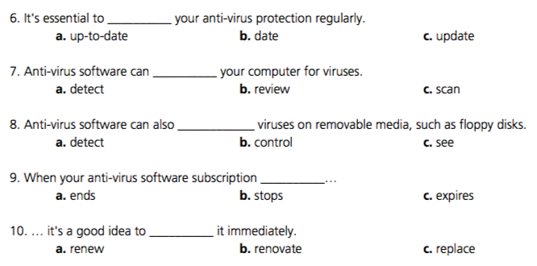

**Part H**

***III. Choose the correct answer to complete the sentences***

1. **It’s important ______ programming languages with markup languages.  
   a. not confuse b. not to confuse c. don’t confuse**
2. **Markup languages are used ____ the structure of web documents.  
   a. for describe b. describe c. to describe**
3. **You must learn _____ effective business letters.  
   a. to write b. write c. writing**
4. **Mr Keller has asked me _____ you these files.  
   a. send b. sending c. to send**
5. **This program will make this old PC _____ faster.  
   a. running b. run c. to run**
6. **We use high-level languages because machine code is too difficult_______, understand and debug.  
   a. read b. reading c. to read**
7. **I went on the course _____ how to be a better programmer  
   a. learn b. to learn c. for to learn**
8. **I’m not interested in ______ that computer language  
   a. learn b. learning c. to learn**
9. **He refuses ______ the project with me.  
   a. do b. doing c. to do**
10. **The engineers warned the employees not _____ the cables.  
    a. touch b. touching c. to touch**
11. **They may not _____ to the conference.  
    a. come b. coming c. to come**
12. **Spyware can make your PC ______ more slowly.  
    a. perform b. performing c. to perform**
13. **This program is too slow_______ the simulation.  
    a. do b. to do c. for doing**